__hr__
How are These Simulations Created?
space
Simulating any type of fluid flow realistically with the Navier-Stokes equations, even for seemingly simple flows like those considered here, is actually a very difficult and complicated process. The reason for this is that, as stated in the “Setting Up the Problem” page, these equations constitute a system of simultaneous, nonlinear, partial differential equations.

Using the dimensionless parameters defined previously, the dimensionless Navier-Stokes equations in two Cartesian coordinates are written as
space
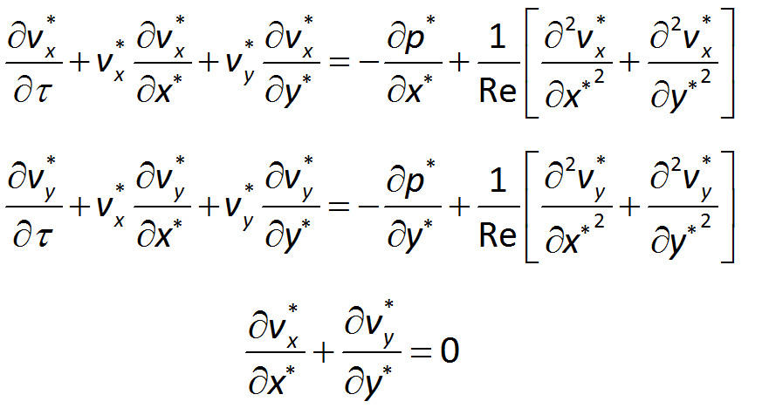
space
Herest,sx, andsy are the time and thesx- andsy-coordinates,sv_{x} andsv_{y} are thesx- andsy-components of the velocity vector, andsp is the pressure. The first two equations are versions of Newton’s Second Law (F=ma) for a fluid. The third equation ensures that mass is conserved.

These equations are said to be nonlinear because the second and third terms on the left-hand sides of the first and second equations consist of the product of a velocity component and a derivative of a velocity component.

These equations and their generalizations to three dimensions and to compressible and variable-density flows govern many important fluid flows; from modeling airflow over an aircraft, to flow of water through a pipe, and predicting the weather, and are notoriously difficult to solve. In fact, in their full form, exact solutions are rarely possible, and the most common way to obtain approximate solutions to these equations is to use specialized computer software on very powerful computers.


(Image Credit: SDSC)

The simulations performed on this website are performed on a supercomputer called Comet, hosted at the San Diego Supercomputer Center, one of the national centers for large-scale computing supported by the National Science Foundation. Comet has 47,776 processors (each of which is similar to that in a PC), which are configured to operate simultaneously. Comet is capable at peak performance of ~2 Petaflops or ~2,000,000,000,000,000 floating point operations (i.e., arithmetic operations) per second! The software program that executes these simulations on Comet is a sophisticated computer code called Nek5000, which has been developed over many years at Argonne National Laboratory, a multi-purpose laboratory of the United States Department of Energy.

space
What Does it Mean to Solve a Problem Numerically?
space

“Solving” a difficult set of equations having no exact solution, such as the Navier-Stokes equations, typically means finding a numerical approximation rather than an exact solution. For the Navier-Stokes equations and other nonlinear systems, this is normally done by following an algorithm, which at each value of timest, produces a sequence of approximations to the solution. Algorithms can have many steps and can require many “iterations” to get to a good enough answer, so generally computers are used to carry them out.
space

A bit more detail…

In the videos of the simulations you submit, we have displayed a quantity known as the “spanwise vorticity,” which is defined as:
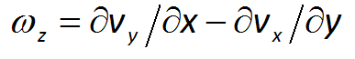
Vorticity is, in a broad sense, a measure of the local rate of rotation of the fluid elements. The “blobs” of red and blue that move downstream of the cylinder are concentrations of spanwise vorticity associated with the “shedding” of vortices by the square cylinder.

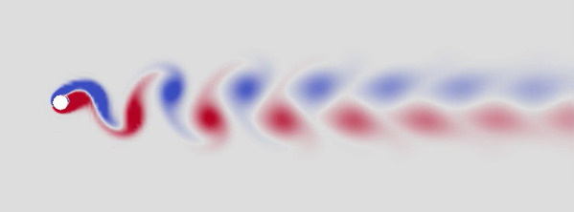

The approximate numerical solution shown in these simulations is obtained by integrating the two-dimensional Navier-Stokes equations, beginning with initial conditions at timest=0. The algorithm used by Nek5000 advances the approximate numerical solution from one time step to the next by a process which approximates the partial differential equations by a large system of nonlinear algebraic equations. This process, known as spatial and temporal discretization, involves breaking up a spatial domain into a large number of “elements” and establishing a sequence of times at which the solution will be approximated.

To perform this discretization, the following items are need:

Temporal discretization normally involves selecting astime-step size, which strongly affects the accuracy of the simulation. When the time-step size is made smaller, the approximate becomes more accurate, but the required computational effort increases. If the time-step size is too large, the simulation will be fast, but it will not be as accurate as it could have been had a smaller time-step size been used.

Spatial discretization is normally accomplished by establishing either a) a “mesh” consisting of a large number of elements; or b) a “grid” consisting of a large number of points. When a mesh of elements is used, the solution is approximated over each element’s area (in 2-D) or volume (in 3-D). Use of a grid results in approximating the solution at each point on the grid. In either case, the solution accuracy depends strongly on the number of points or elements used, as well as on the shape of the elements, or the distribution of the grid points. When the mesh or grid is too coarse, accuracy is lost, and when the mesh is too fine the computational burden become untenable.

When the computational domain (an area in 2-D or a volume in 3-D) is finite (e.g., inside a room, inside the human circulatory system), boundary conditions are applied on physical boundaries, such as a wall. These boundary conditions can account for the fact that a viscous fluid does not “slip” at a solid surface, and for the fact that a fluid does not flow through an impermeable solid.

On the other hand, when the spatial domain is unbounded in one or more directions the approximate numerical solution is invariably performed on a truncated spatial domain, on which approximate boundary conditions are typically applied. Thesdomain size affects the computation as follows. When the domain is too large, either unnecessary mesh elements or grid points will be needed (resulting in excessive computational burden), or the mesh/grid will be too coarse in some areas. If the computational domain is too small, then approximate boundary conditions applied at the computational boundaries will affect the solution in unphysical ways, or the simulation might not capture all the phenomena we want to study.

In a time-dependent simulation, the initial state of the system must be specified, and this is known as thesinitial conditions.

In a time-dependent problem, Nek5000 and other codes typically perform a number ofsiterations at each time step. When the results no longer change from one iterate to the next, the iteration is said to have “converged” and the algorithm moves forward to the next time-step. In Nek5000 and other similar codes, convergence is generally achieved easily and the computational parameter(s) affecting iteration convergence typically has little effect on running time.

Space
For more about the Navier-Stokes Equations:
https://en.wikipedia.org/wiki/Navier%E2%80%93Stokes_equations
For more about Comet:
http://www.sdsc.edu/support/user_guides/comet.html
For more about algorithms and numerical analysis:
https://en.wikipedia.org/wiki/Numerical_analysis

__imagesize:original__

__hr__

